Data Flow Diagrams and User Stories
Incident Lifecycle Automation in ServiceNow

1. Purpose
This document describes the main information flow in the proposed incident management process and captures user stories that can guide configuration and testing. Diagrams and stories should be checked against the actual ServiceNow instance and approved scope.

2. Context-level data flow
- External actor: End user — submits incident details and receives permitted status updates.
- Process: ServiceNow Incident Management — records the incident, manages lifecycle state, supports assignment and resolution, and stores the record.
- Supporting process: Knowledge Management — provides articles that agents may consult during investigation.
- Related process: Change Management — may be used when resolution requires a controlled system change; it is not a substitute for incident handling.
- Data store: Incident records — contain reported details, category, priority, assignment, state, work notes, resolution information, and relevant timestamps subject to configured fields and access controls.

3. Text representation of the data flow
- End user → Incident submission → ServiceNow incident record
- ServiceNow incident record → Categorisation / prioritisation → Assignment group
- Assigned support agent ↔ Incident record (investigation, updates, work notes)
- Support agent → Knowledge Management (search and apply relevant guidance)
- Support agent → Resolution details → Resolved / Closed state, according to configured process
- Incident requiring controlled change → Change Management process → Related change record, where appropriate

4. User stories
- US-01 — As an end user, I want to submit an incident with a description and relevant details so that the support team can understand the issue.
- US-02 — As a service desk agent, I want incidents to be categorised and prioritised consistently so that urgent issues can be handled appropriately.
- US-03 — As a support agent, I want to assign an incident to the appropriate support group so that the team responsible can investigate it.
- US-04 — As an end user, I want to see permitted status updates so that I know whether my issue is being handled.
- US-05 — As a support agent, I want to search relevant Knowledge articles so that I can reuse existing troubleshooting guidance.
- US-06 — As a support agent, I want to record resolution notes so that the solution is clear and can help with future incidents.
- US-07 — As a process owner, I want incident records to retain lifecycle and resolution information so that the process can be reviewed.
- US-08 — As a support agent, I want to link a related change when an incident requires a controlled change so that the work follows the appropriate process.

5. Acceptance criteria examples
Incident submission: a record is saved with required fields and a unique incident number, subject to platform configuration.
Prioritisation: impact and urgency are recorded and priority follows the approved rules.
Assignment: the record shows the selected assignment group and assigned person where applicable.
Status communication: permitted users can view the current state and receive configured notifications, if included in scope.
Resolution: resolution code and notes are captured according to the configured requirements before closure.
Access: users can view or update records only as allowed by roles and access controls.

6. Data and privacy considerations
Use sample or anonymised data in project demonstrations. Restrict access to incident records, work notes, and any sensitive details according to the organisation's access policies.

User story tracking template
ID | Priority | Acceptance test / evidence | Status

4. High-Level Data Flow Diagram
Proposed information flow; validate against the final configured instance.
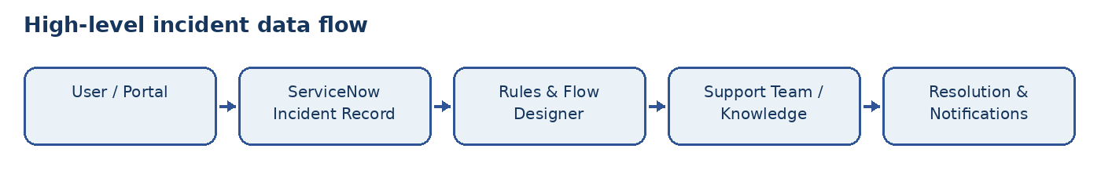

Process Diagram
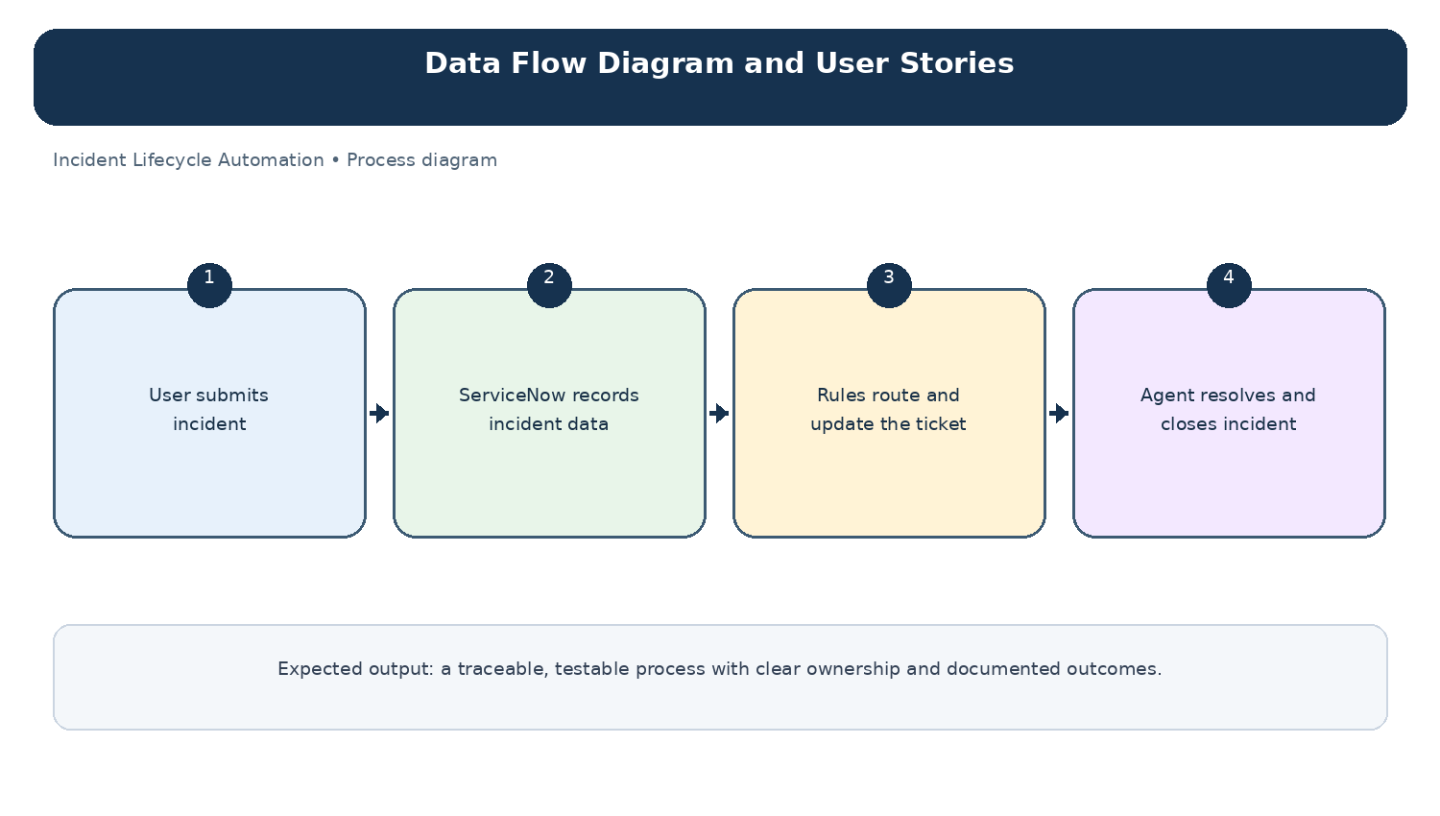
Diagram: Data Flow Diagram and User Stories — project-specific process overview.

